Creating a OneNote Class Notebook from Scratch

1)Use the OneNote App (under your start menu) Not OneNote 2016, the one that just says “OneNote”

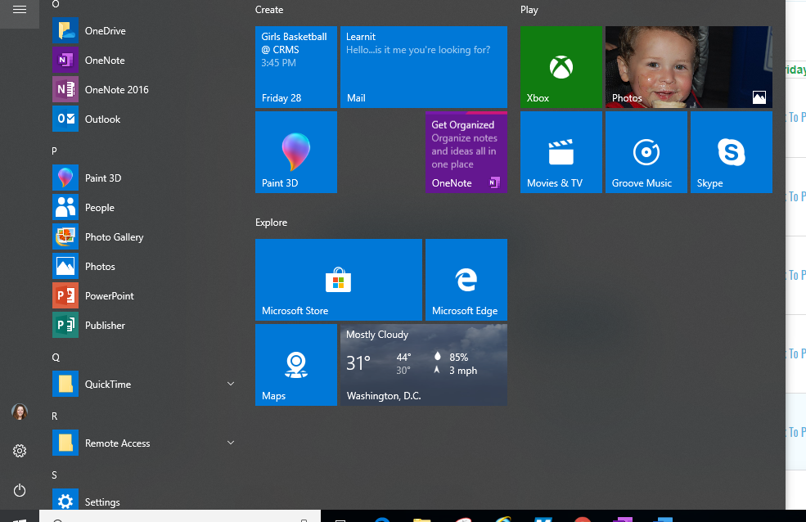

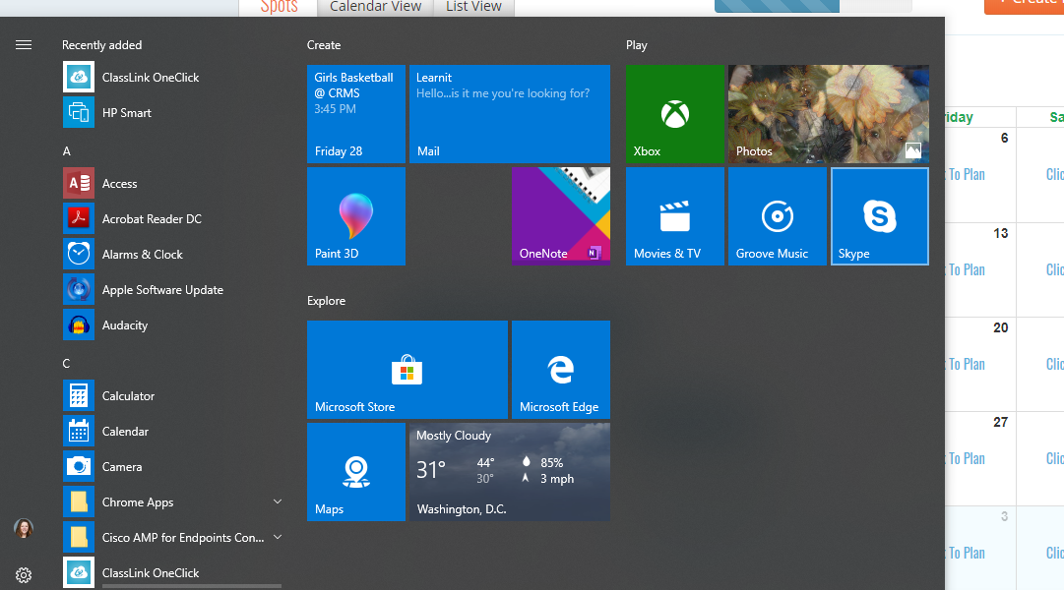



2) Click on the tab “Class Notebook” and the icon to create a new notebook. This will take you into Office365 Online



3) There you will

* Name it
* Add Co-teachers (type in their name)
* Add Students (copy and paste their emails from the “Email Class function in PowerSchool)
* Set up Sections for Students (Note this does not create teacher sections)
  + You can always add later, but you can’t delete, so it is best to only add what you really want at this point

4) after you have finished setting it up- click on “Open in OneNote”- Again you want to pick OneNote not OneNote 2016 when given the choice. Alternatively, you can switch back to the app, and click on the drop-down arrow next to the name of your current notebook and select “More Notebooks” to find the one you just created.

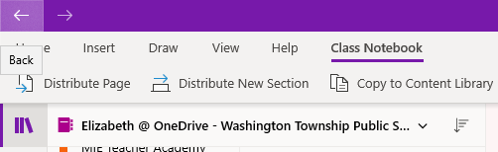

5) The last step will be to set up the teacher sections and start building content. There is no right or wrong way to organize a notebook. It can be done by

* Unit
* Topic
* Type of work
* Week
* Anything that makes sense to you.

